PROJECT REPORT

**CREATING A SPONSORED POST FOR INSTAGRAM**

1. **INTRODUCTION**

# **Overview**

# The main objective of this project is to Create a sponsored post for Instagram. In the dynamic realm of social media marketing, Instagram has emerged as a pivotal platform for brands and businesses to connect with their audience. Sponsored posts on Instagram have become a vital component of advertising strategies, enabling companies to engage with users in a visually compelling and interactive way. These sponsored posts allow businesses to promote their products or services while leveraging the platform's diverse functionalities to reach a wider audience. Crafting an effective sponsored post on Instagram involves understanding the platform's nuances, user behavior, and the art of creating engaging content that resonates with the target audience.

# **1.2Purpose**

The primary purpose of creating sponsored posts on Instagram is to expand

brand visibility ,drive user engagement , and ultimately, achieve marketing

objective. These posts serve as a bridge between businesses and their target \

audience

1. **PROBLEM DEFINITION AND DESIGN THINKING**
   1. Empathy Map

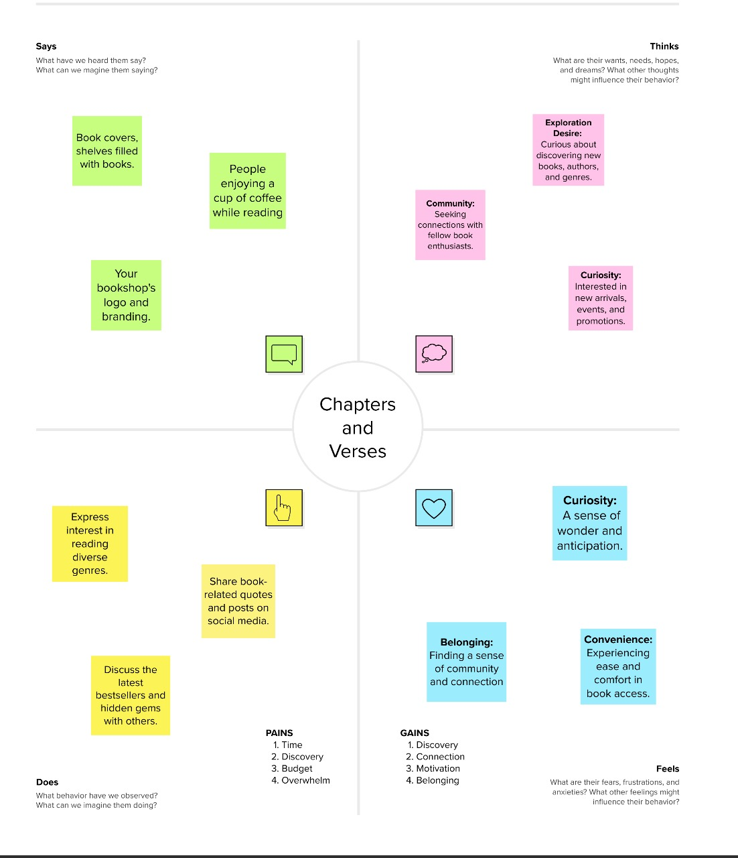

# **Ideation and Brainstorming Map**

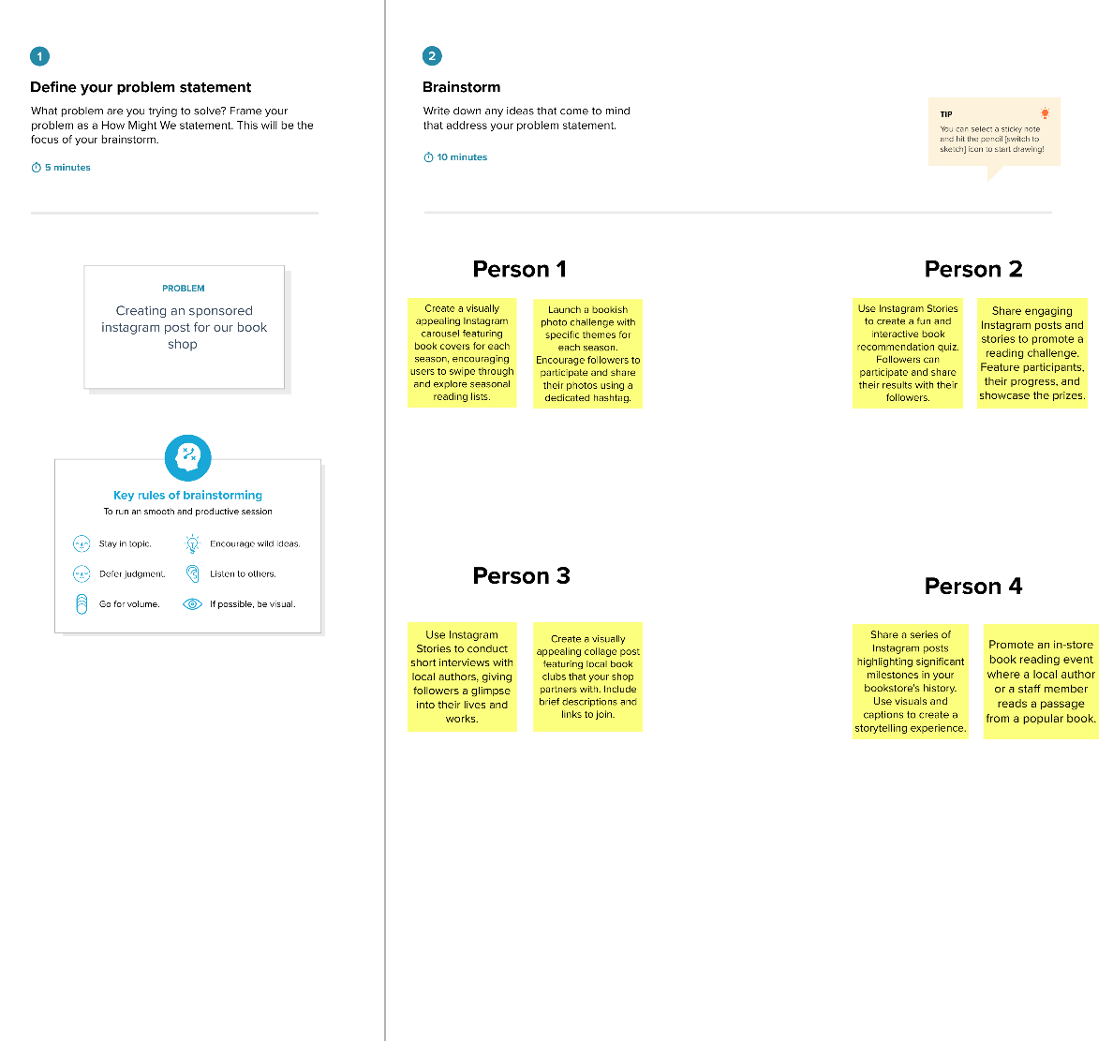

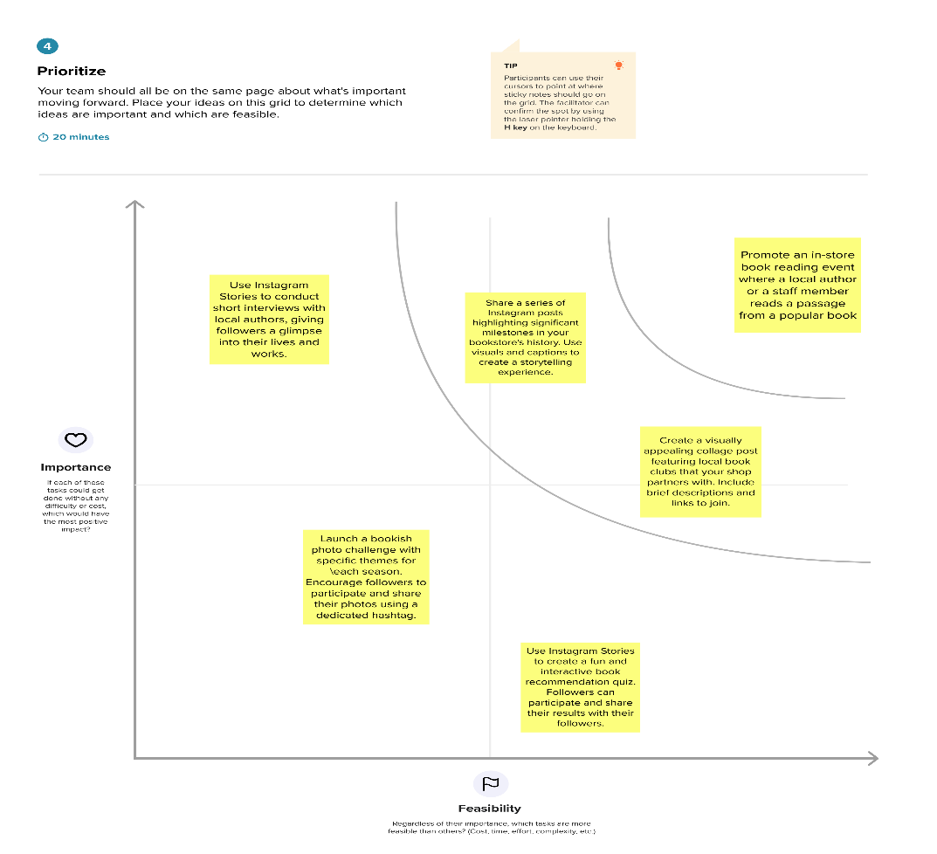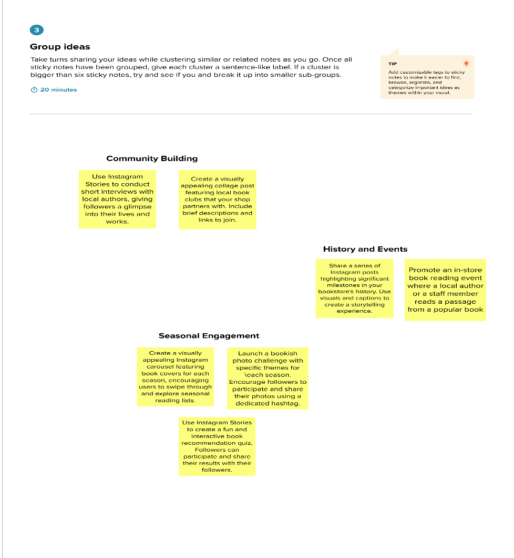

1. **RESULTS**

The creation of our sponsored post for Instagram has yielded significant results. It emphasizes the strategic process necessary to create compelling content, highlighting the significance of understanding the target audience, optimizing visual and textual elements, and utilizing the platform's diverse features.



# **ADVANTAGES AND DISADVANTAGES**

# **ADVANTAGES**

# Enhanced Reach: Sponsored posts allow businesses to extend their reach beyond their existing followers, targeting specific demographics or interests, thereby increasing brand visibility.

# Targeted Advertising: Leveraging Instagram's robust targeting options enables precise audience segmentation based on demographics, interests, behaviors, and more, ensuring the content reaches the intended audience.

# Increased Engagement: Visually appealing content combined with engaging captions prompts higher user interaction, encouraging likes, comments, shares, and click-throughs, boosting engagement metrics.

# Credibility and Trust: Collaborating with influencers or authoritative figures in the industry can build credibility for the brand, as recommendations from influencers often carry weight with their followers.

# Measurable Performance: Instagram Insights and other analytics tools provide measurable data, allowing brands to track the performance of sponsored posts and make data-driven decisions for future campaigns.

# **DISADVANTAGES**

# Costs: Running sponsored posts on Instagram incurs costs, which may be prohibitive for smaller businesses. The expenses can vary based on the campaign objectives and audience size.

# Ad Saturation: The platform's growing popularity has led to an increased volume of sponsored content, which might result in ad fatigue or oversaturation, reducing the effectiveness of individual posts.

# Audience Skepticism: Some users are becoming more wary of sponsored content, potentially leading to skepticism or reduced trust in the authenticity of such posts.

# Ad Blocking or Ignoring: Some users might instinctively ignore or use ad-blocking tools, diminishing the visibility and impact of sponsored posts.

# Influencer Risks: Collaborating with influencers carries the risk of associating the brand with unforeseen controversies or negative publicity if the influencer faces issues or behaves inappropriately.

# **APPLICATION**

By comprehending the demographics and preferences of the target audience, brands can create content that resonates, such as showcasing fitness products to a young adult audience interested in health. Creating visually appealing posts with engaging captions that reflect brand identity is pivotal, using various Instagram features like Stories, IGTV, or Reels to diversify content and increase interactivity. Collaborating with influencers or leveraging targeted ads enhances the reach and impact of these posts. Including a clear call-to-action prompts user engagement, whether it's exploring a website or participating in a poll. Regular performance analysis through metrics allows for optimizations and adjustments, ensuring that sponsored posts consistently meet marketing objectives and resonate effectively with the audience.

# **CONCLUSION**

In conclusion, the process of crafting sponsored posts on Instagram stands as a dynamic and multifaceted strategy essential for modern marketing. By understanding the audience, optimizing visual and textual content, and leveraging the platform's diverse features, businesses can effectively enhance brand visibility and engagement.